Experiment 3

Email Spam or Ham Classification using Naive Bayes, KNN, and SVM

**Name:** Vigneshwaran S **Reg no**:3122237001059

**Git Hub:** https://github.com/Vignesh-0013/Machine_Learning

# Aim:

To develop and evaluate supervised machine learning models using K-Nearest Neighbors (KNN)

and Naive Bayes (Bernoulli, Multinomial, Gaussian) classifiers. To analyze and compare the performance

of these models on a given dataset using accuracy and other evaluation metrics.

# Libraries used:

* + Numpy
  + Pandas
  + Matplotlib
  + Scikit-learn
  + Seaborn

# Objective:

* + To implement KNN and Naive Bayes algorithms for classification, including preprocessing, training, and testing using appropriate techniques such as cross-validation.
  + To assess the models using metrics like accuracy, precision, recall, F1-score, confusion matrix,

ROC curve, and AUC, and to present a comparative analysis.

**Code**

In [18]:

**import** pandas **as** pd

**import** numpy **as** np

**from** sklearn.model_selection **import** train_test_split, cross_val_score, KFold

**from** sklearn.preprocessing **import** StandardScaler

**from** sklearn.metrics **import** accuracy_score, precision_score, recall_score, f1_sc

**import** matplotlib.pyplot **as** plt

**import** seaborn **as** sns

In [2]:

*#Load dataset*

df **=** pd**.**read_csv("Dataset/spambase_csv.csv") print(df**.**shape)

print(df**.**head())

print(df**.**describe())

(4601, 58)

word_freq_make word_freq_address word_freq_all word_freq_3d \

0 0.00 0.64 0.64 0.0

1 0.21 0.28 0.50 0.0

2 0.06 0.00 0.71 0.0

3 0.00 0.00 0.00 0.0

4 0.00 0.00 0.00 0.0

word_freq_our word_freq_over word_freq_remove word_freq_internet \

0 0.32 0.00 0.00 0.00

1 0.14 0.28 0.21 0.07

2 1.23 0.19 0.19 0.12

3 0.63 0.00 0.31 0.63

4 0.63 0.00 0.31 0.63

word_freq_order word_freq_mail ... char_freq_%3B char_freq_%28 \

0 0.00 0.00 ... 0.00 0.000

1 0.00 0.94 ... 0.00 0.132

2 0.64 0.25 ... 0.01 0.143

3 0.31 0.63 ... 0.00 0.137

4 0.31 0.63 ... 0.00 0.135

char_freq_%5B char_freq_%21 char_freq_%24 char_freq_%23 \

0 0.0 0.778 0.000 0.000

1 0.0 0.372 0.180 0.048

2 0.0 0.276 0.184 0.010

3 0.0 0.137 0.000 0.000

4 0.0 0.135 0.000 0.000

capital_run_length_average capital_run_length_longest \

0 3.756 61

1 5.114 101

2 9.821 485

3 3.537 40

4 3.537 40

|  |  |  |
| --- | --- | --- |
|  | capital_run_length_total | class |
| 0 | 278 | 1 |
| 1 | 1028 | 1 |
| 2 | 2259 | 1 |
| 3 | 191 | 1 |
| 4 | 191 | 1 |

|  |  |  |  |  |  |  |  |
| --- | --- | --- | --- | --- | --- | --- | --- |
| [5 rows x 58 columns]  word_freq_make | | word_freq_address | | word_freq_all | word_freq_3d | \ | |
| count 4601.000000 | | 4601.000000 | | 4601.000000 | 4601.000000 |  | |
| mean 0.104553 | | 0.213015 | | 0.280656 | 0.065425 |  | |
| std 0.305358 | | 1.290575 | | 0.504143 | 1.395151 |  | |
| min 0.000000 | | 0.000000 | | 0.000000 | 0.000000 |  | |
| 25% 0.000000 | | 0.000000 | | 0.000000 | 0.000000 |  | |
| 50% 0.000000 | | 0.000000 | | 0.000000 | 0.000000 |  | |
| 75% 0.000000 | | 0.000000 | | 0.420000 | 0.000000 |  | |
| max 4.540000 | | 14.280000 | | 5.100000 | 42.810000 |  | |
|  | word_freq_our | word_freq_over | word_freq_remove | | word_freq_internet | | \ |
| count | 4601.000000 | 4601.000000 | 4601.000000 | | 4601.000000 | |  |
| mean | 0.312223 | 0.095901 | 0.114208 | | 0.105295 | |  |
| std | 0.672513 | 0.273824 | 0.391441 | | 0.401071 | |  |
| min | 0.000000 | 0.000000 | 0.000000 | | 0.000000 | |  |
| 25% | 0.000000 | 0.000000 | 0.000000 | | 0.000000 | |  |

|  |  |  |  |  |  |  |  |
| --- | --- | --- | --- | --- | --- | --- | --- |
| 50% | 0.000000 | 0.000000 | 0.000000 | | 0.000000 | | |
| 75% | 0.380000 | 0.000000 | 0.000000 | | 0.000000 | | |
| max | 10.000000 | 5.880000 | 7.270000 | | 11.110000 | | |
|  | word_freq_order | word_freq_mail ... char_freq_%3B | | | char_freq_%28 | | \ |
| count | 4601.000000 | 4601.000000 ... 4601.000000 | | | 4601.000000 | |  |
| mean | 0.090067 | 0.239413 ... 0.038575 | | | 0.139030 | |  |
| std | 0.278616 | 0.644755 ... 0.243471 | | | 0.270355 | |  |
| min | 0.000000 | 0.000000 ... 0.000000 | | | 0.000000 | |  |
| 25% | 0.000000 | 0.000000 ... 0.000000 | | | 0.000000 | |  |
| 50% | 0.000000 | 0.000000 ... 0.000000 | | | 0.065000 | |  |
| 75% | 0.000000 | 0.160000 ... 0.000000 | | | 0.188000 | |  |
| max | 5.260000 | 18.180000 ... 4.385000 | | | 9.752000 | |  |
|  | char_freq_%5B | char_freq_%21 | char_freq_%24 | char_freq_%23 | | \ | |
| count | 4601.000000 | 4601.000000 | 4601.000000 | 4601.000000 | |  | |
| mean | 0.016976 | 0.269071 | 0.075811 | 0.044238 | |  | |
| std | 0.109394 | 0.815672 | 0.245882 | 0.429342 | |  | |
| min | 0.000000 | 0.000000 | 0.000000 | 0.000000 | |  | |
| 25% | 0.000000 | 0.000000 | 0.000000 | 0.000000 | |  | |
| 50% | 0.000000 | 0.000000 | 0.000000 | 0.000000 | |  | |
| 75% | 0.000000 | 0.315000 | 0.052000 | 0.000000 | |  | |
| max | 4.081000 | 32.478000 | 6.003000 | 19.829000 | |  | |

|  |  |  |  |
| --- | --- | --- | --- |
|  | capital_run_length_average | capital_run_length_longest | \ |
| count | 4601.000000 | 4601.000000 |  |
| mean | 5.191515 | 52.172789 |  |
| std | 31.729449 | 194.891310 |  |
| min | 1.000000 | 1.000000 |  |
| 25% | 1.588000 | 6.000000 |  |
| 50% | 2.276000 | 15.000000 |  |
| 75% | 3.706000 | 43.000000 |  |
| max | 1102.500000 | 9989.000000 |  |
|  | capital_run_length_total | class | |
| count | 4601.000000 | 4601.000000 | |
| mean | 283.289285 | 0.394045 | |
| std | 606.347851 | 0.488698 | |
| min | 1.000000 | 0.000000 | |
| 25% | 35.000000 | 0.000000 | |
| 50% | 95.000000 | 0.000000 | |
| 75% | 266.000000 | 1.000000 | |
| max | 15841.000000 | 1.000000 | |

[8 rows x 58 columns]

In [19]:

*#Missing Values*

print(df**.**isnull()**.**sum())

df**.**fillna(df**.**mean(), inplace**=True**)

word_freq_make 0

word_freq_address 0

word_freq_all 0

word_freq_3d 0

word_freq_our 0

word_freq_over 0

word_freq_remove 0

word_freq_internet 0

word_freq_order 0

word_freq_mail 0

word_freq_receive 0

word_freq_will 0

word_freq_people 0

word_freq_report 0

word_freq_addresses 0

word_freq_free 0

word_freq_business 0

word_freq_email 0

word_freq_you 0

word_freq_credit 0

word_freq_your 0

word_freq_font 0

word_freq_000 0

word_freq_money 0

word_freq_hp 0

word_freq_hpl 0

word_freq_george 0

word_freq_650 0

word_freq_lab 0

word_freq_labs 0

word_freq_telnet 0

word_freq_857 0

word_freq_data 0

word_freq_415 0

word_freq_85 0

word_freq_technology 0

word_freq_1999 0

word_freq_parts 0

word_freq_pm 0

word_freq_direct 0

word_freq_cs 0

word_freq_meeting 0

word_freq_original 0

word_freq_project 0

word_freq_re 0

word_freq_edu 0

word_freq_table 0

word_freq_conference 0

char_freq_%3B 0

char_freq_%28 0

char_freq_%5B 0

char_freq_%21 0

char_freq_%24 0

char_freq_%23 0

capital_run_length_average 0

capital_run_length_longest 0

capital_run_length_total 0

class 0

dtype: int64

In [20]:

*#Target*

print(df['class']**.**nunique())

print(df['class']**.**unique())

2

[1 0]

In [21]:

*#Duplicate*

df**.**duplicated()**.**sum()

Out[21]:

In [22]:

Out[22]:

391

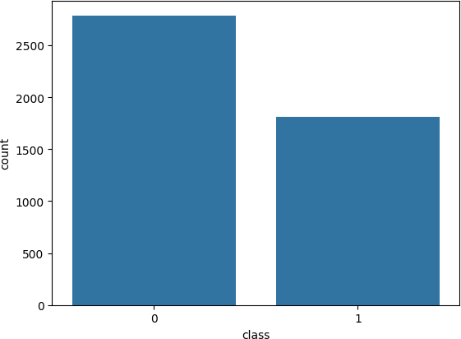

*#target Class Distribution*

sns**.**countplot(x**=**'class', data**=**df) plt**.**show()

df['class']**.**value_counts()**.**plot**.**pie(autopct**=**'%1.1f%%')

<Axes: ylabel='count'>

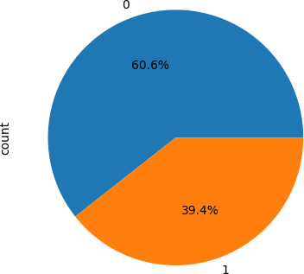

In [23]:

df**.**columns

Out[23]:

In [24]:

Index(['word_freq_make', 'word_freq_address', 'word_freq_all', 'word_freq_3d', 'word_freq_our', 'word_freq_over', 'word_freq_remove',

'word_freq_internet', 'word_freq_order', 'word_freq_mail', 'word_freq_receive', 'word_freq_will', 'word_freq_people',

'word_freq_report', 'word_freq_addresses', 'word_freq_free', 'word_freq_business', 'word_freq_email', 'word_freq_you',

'word_freq_credit', 'word_freq_your', 'word_freq_font', 'word_freq_000', 'word_freq_money', 'word_freq_hp', 'word_freq_hpl', 'word_freq_george', 'word_freq_650', 'word_freq_lab', 'word_freq_labs', 'word_freq_telnet', 'word_freq_857', 'word_freq_data', 'word_freq_415', 'word_freq_85',

'word_freq_technology', 'word_freq_1999', 'word_freq_parts',

'word_freq_pm', 'word_freq_direct', 'word_freq_cs', 'word_freq_meeting', 'word_freq_original', 'word_freq_project', 'word_freq_re',

'word_freq_edu', 'word_freq_table', 'word_freq_conference',

'char_freq_%3B', 'char_freq_%28', 'char_freq_%5B', 'char_freq_%21', 'char_freq_%24', 'char_freq_%23', 'capital_run_length_average',

'capital_run_length_longest', 'capital_run_length_total', 'class'], dtype='object')

*#Numeric Features #Histogram*

num_cols **=** len(df**.**columns)

n_cols **=** 3

n_rows **=** (num_cols **+** n_cols **-** 1) **//** n_cols

fig, axes **=** plt**.**subplots(n_rows, n_cols, figsize**=**(15, 4 **\*** n_rows)) axes **=** axes**.**flatten()

**for** i, col **in** enumerate(df**.**columns[:10]):

axes[i]**.**hist(df[col]**.**dropna(), bins**=**20, color**=**'skyblue', edgecolor**=**'black') axes[i]**.**set_title(col)

axes[i]**.**set_ylabel('Frequency') axes[i]**.**set_xlabel('Value')

**for** j **in** range(i **+** 1, len(axes)): fig**.**delaxes(axes[j])

plt**.**tight_layout() plt**.**show()

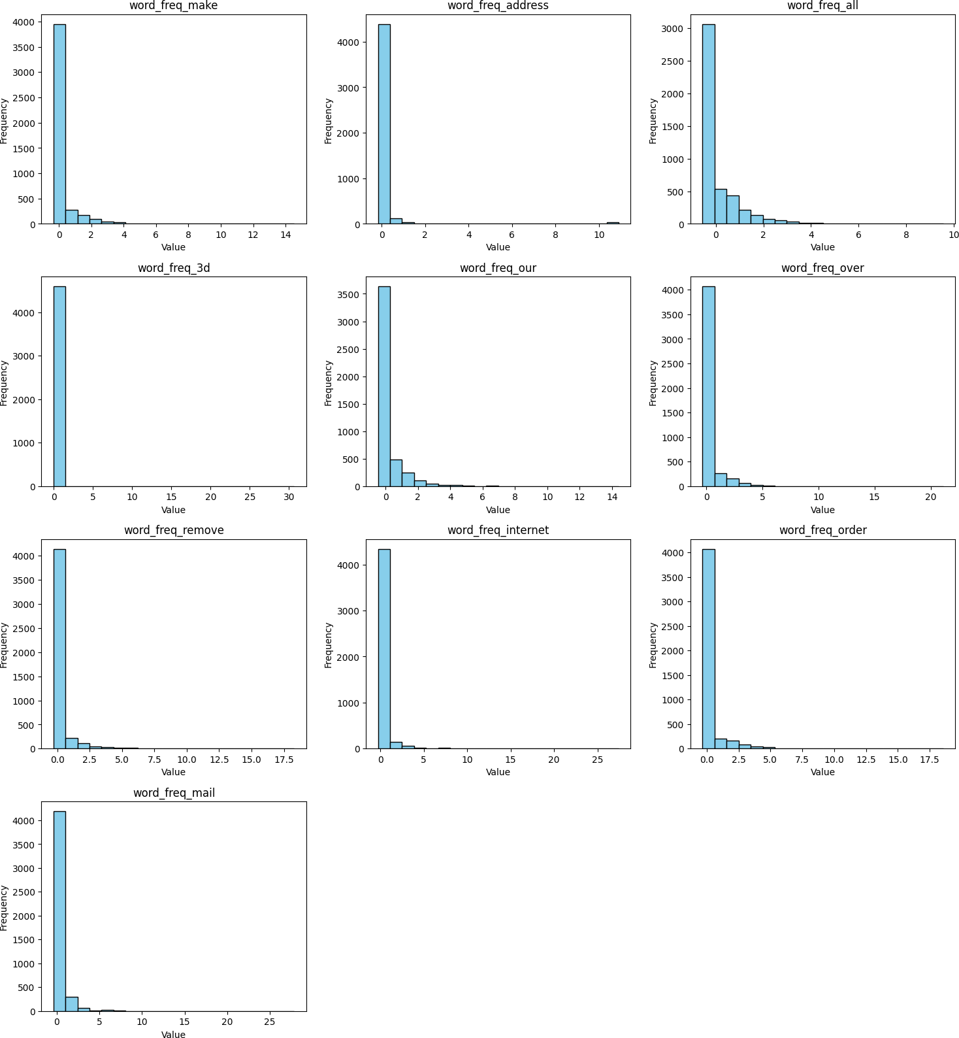

In [25]:

*#Boxplot*

numeric_cols **=** df**.**select_dtypes(include**=**['int64', 'float64'])**.**columns num_cols **=** len(numeric_cols)

*# Define subplot grid size*

n_cols **=** 3 *# number of plots per row*

n_rows **=** (num_cols **+** n_cols **-** 1) **//** n_cols *# ceiling division*

*# Create subplots*

fig, axes **=** plt**.**subplots(n_rows, n_cols, figsize**=**(15, 4 **\*** n_rows)) axes **=** axes**.**flatten()

*# Plot boxplot for each numeric column*

**for** i, col **in** enumerate(numeric_cols[:10]):

axes[i]**.**boxplot(df[col]**.**dropna(), vert**=True**, patch_artist**=True**, boxprops**=**dict(facecolor**=**'skyblue'))

axes[i]**.**set_title(col)

axes[i]**.**set_ylabel('Value')

*# Remove unused subplots*

**for** j **in** range(i **+** 1, len(axes)): fig**.**delaxes(axes[j])

plt**.**tight_layout() plt**.**show()

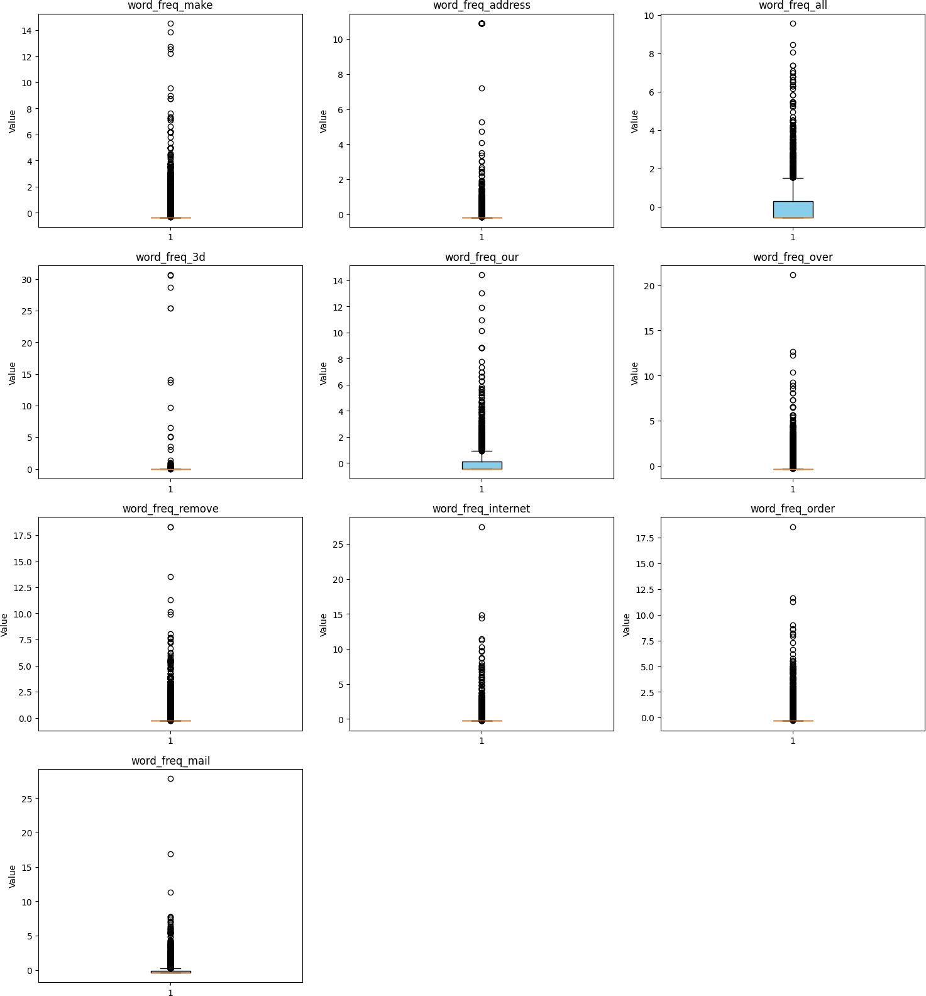

In [10]:

*#Feature vs target relation #HeattMap*

plt**.**figure(figsize**=**(20,20))

sns**.**heatmap(df**.**groupby('class')**.**mean(), annot**=True**)

Out[10]: <Axes: ylabel='class'>

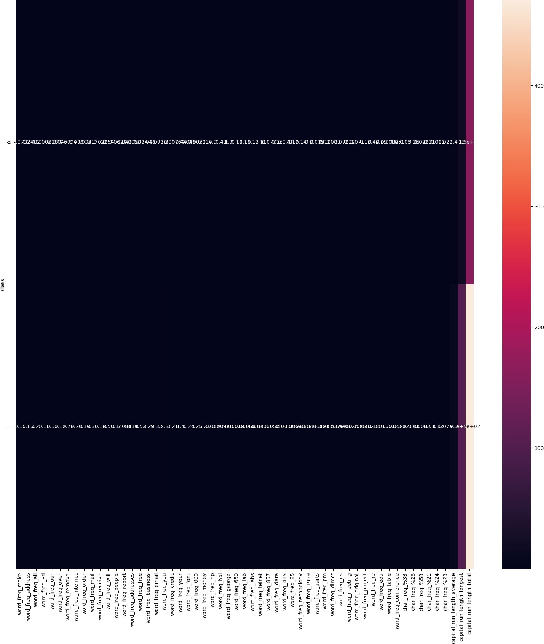

In [11]:

*#Correlation Heatmap*

plt**.**figure(figsize**=**(50,50))

corr **=** df**.**corr(numeric_only**=True**)

sns**.**heatmap(corr, annot**=True**, cmap**=**'coolwarm')

Out[11]: <Axes: >

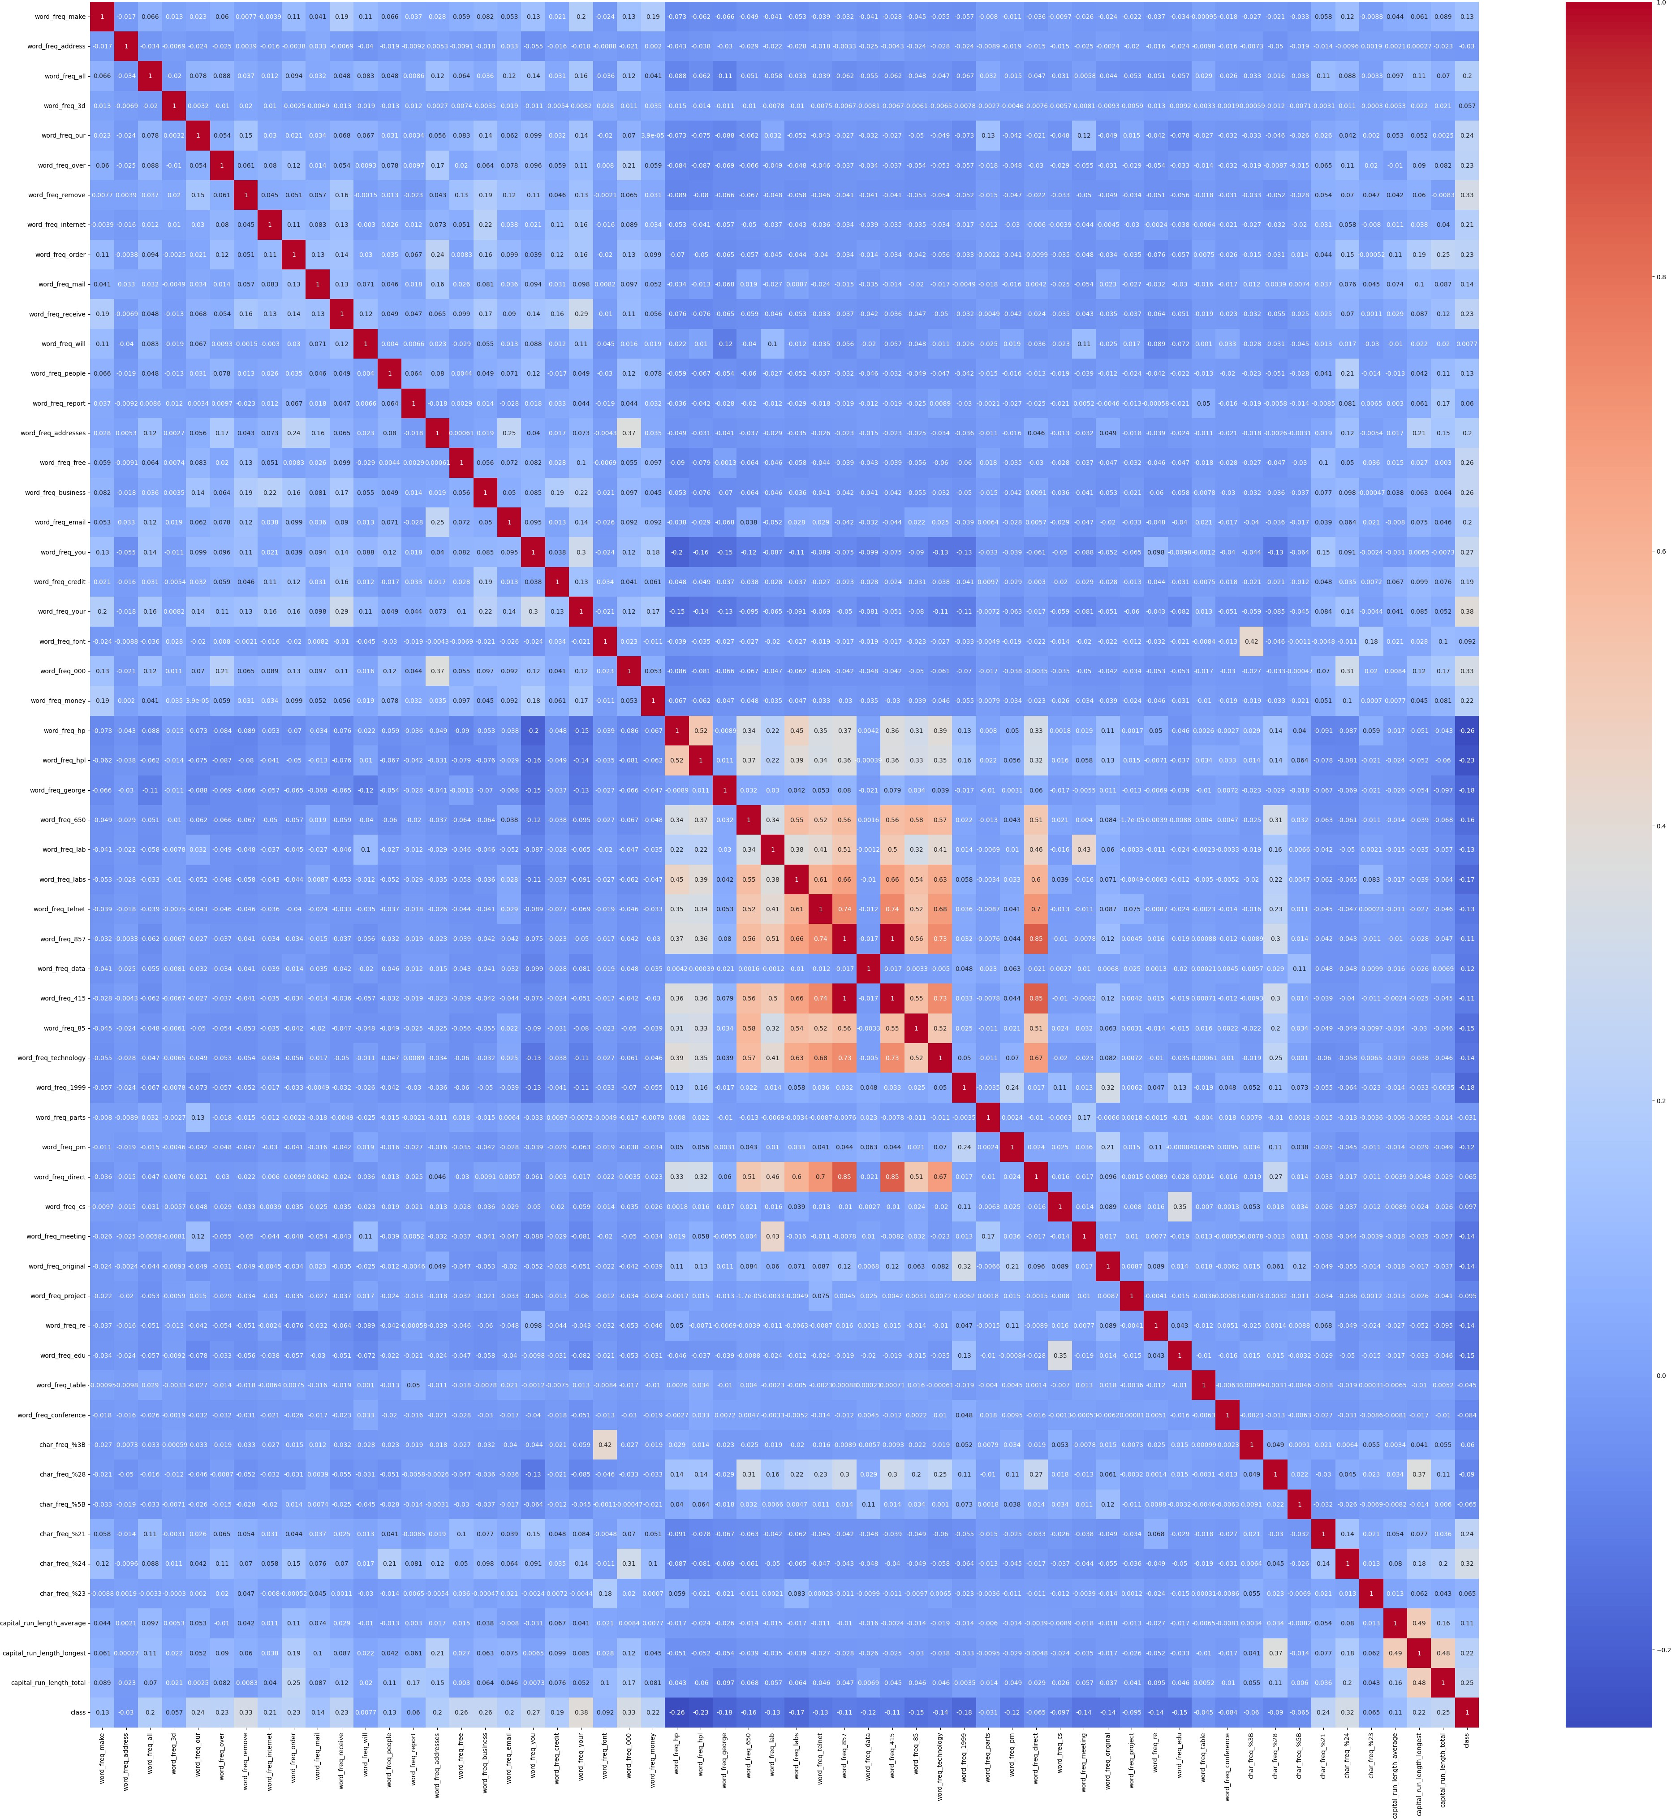

In [12]:

*#Standardization*

X **=** df**.**drop('class', axis**=**1) y **=** df['class']

scaler **=** StandardScaler()

X_scaled **=** pd**.**DataFrame(scaler**.**fit_transform(X), columns**=**X**.**columns) df**=** pd**.**concat([X_scaled, y], axis**=**1)

print(df**.**head())

word_freq_make word_freq_address word_freq_all word_freq_3d \

0 -0.342434 0.330885 0.712859 -0.0469

1 0.345359 0.051909 0.435130 -0.0469

2 -0.145921 -0.165072 0.851723 -0.0469

3 -0.342434 -0.165072 -0.556761 -0.0469

4 -0.342434 -0.165072 -0.556761 -0.0469

word_freq_our word_freq_over word_freq_remove word_freq_internet \

0 0.011565 -0.350266 -0.291794 -0.262562

1 -0.256117 0.672399 0.244743 -0.088010

2 1.364846 0.343685 0.193644 0.036670

3 0.472573 -0.350266 0.500237 1.308402

4 0.472573 -0.350266 0.500237 1.308402

word_freq_order word_freq_mail ... char_freq_%3B char_freq_%28 \

0 -0.323302 -0.371364 ... -0.158453 -0.514307

1 -0.323302 1.086711 ... -0.158453 -0.026007

2 1.974017 0.016422 ... -0.117376 0.014684

3 0.789462 0.605857 ... -0.158453 -0.007511

4 0.789462 0.605857 ... -0.158453 -0.014910

|  |  |  |  |  |  |
| --- | --- | --- | --- | --- | --- |
|  | char_freq_%5B | char_freq_%21 | char_freq_%24 | char_freq_%23 | \ |
| 0 | -0.155198 | 0.624007 | -0.308355 | -0.103048 |  |
| 1 | -0.155198 | 0.126203 | 0.423783 | 0.008763 |  |
| 2 | -0.155198 | 0.008496 | 0.440053 | -0.079754 |  |
| 3 | -0.155198 | -0.161934 | -0.308355 | -0.103048 |  |
| 4 | -0.155198 | -0.164387 | -0.308355 | -0.103048 |  |

|  |  |  |  |  |
| --- | --- | --- | --- | --- |
|  |  | capital_run_length_average | capital_run_length_longest | \ |
| 0 | -0.045247 | 0.045298 |  |
| 1 | -0.002443 | 0.250563 |  |
| 2 | 0.145921 | 2.221106 |  |
| 3 | -0.052150 | -0.062466 |  |
| 4 | -0.052150 | -0.062466 |  |
|  | capital_run_length_total | class |  |
| 0 | -0.008724 | 1 |  |
| 1 | 1.228324 | 1 |  |
| 2 | 3.258733 | 1 |  |
| 3 | -0.152222 | 1 |  |
| 4 | -0.152222 | 1 |  |
| [5 | rows x 58 columns] |  |  |
| In [13]: |  |  |  |  |

In [ ]:

**from** sklearn.naive_bayes **import** GaussianNB

X_train, X_test, y_train, y_test **=** train_test_split(X_scaled, y, test_size**=**0.2, gnb **=** GaussianNB()

gnb**.**fit(X_train, y_train)

**from** sklearn.naive_bayes **import** BernoulliNB

X_train, X_test, y_train, y_test **=** train_test_split(X_scaled, y, test_size**=**0.2, bnb **=** BernoulliNB()

bnb**.**fit(X_train, y_train)

y_pred **=** bnb**.**predict(X_test)

y_prob **=** bnb**.**predict_proba(X_test)[:, 1]

y_pred **=** gnb**.**predict(X_test)

y_prob **=** gnb**.**predict_proba(X_test)[:, 1]

In [15]:

**from** sklearn.metrics **import** accuracy_score, precision_score, recall_score, f1_sc

acc **=** accuracy_score(y_test, y_pred) prec **=** precision_score(y_test, y_pred) rec **=** recall_score(y_test, y_pred)

f1 **=** f1_score(y_test, y_pred)

fpr, tpr, _ **=** roc_curve(y_test, y_prob) roc_auc **=** auc(fpr, tpr)

print(f"\n 'Bernoulli Results") print(f"Accuracy: {acc:.4f}") print(f"Precision: {prec:.4f}") print(f"Recall: {rec:.4f}")

print(f"F1-Score: {f1:.4f}")

print(f"AUC: {roc_auc:.4f}")

*# Confusion Matrix*

cm **=** confusion_matrix(y_test, y_pred)

sns**.**heatmap(cm, annot**=True**, fmt**=**'d', cmap**=**'Blues') plt**.**title(f'Confusion Matrix - Bernoulli')

plt**.**xlabel('Predicted') plt**.**ylabel('Actual')

plt**.**show()

*# ROC Curve*

plt**.**plot(fpr, tpr, label**=**f'Bernoulli (AUC = {roc_auc:.4f})') plt**.**plot([0, 1], [0, 1], 'k--')

plt**.**title(f'ROC Curve - Bernoulli') plt**.**xlabel('False Positive Rate')

plt**.**ylabel('True Positive Rate') plt**.**legend()

plt**.**grid(**True**) plt**.**show()

'Bernoulli Results

|  |  |
| --- | --- |
| Accuracy: | 0.9012 |
| Precision: | 0.9024 |
| Recall: | 0.8402 |
| F1-Score: | 0.8702 |
| AUC: | 0.9604 |

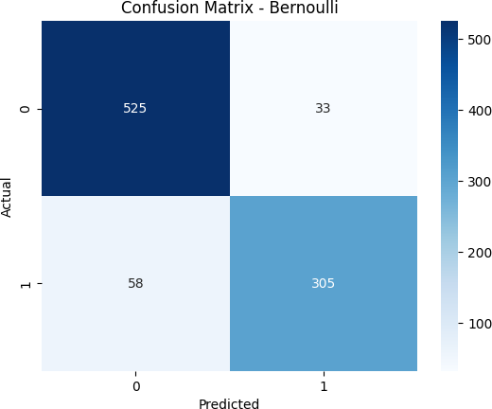

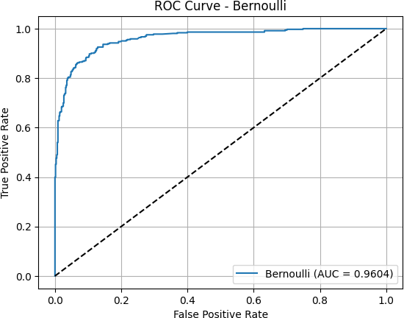

In [16]:

**from** sklearn.model_selection **import** StratifiedKFold, cross_val_score

print("----- K-Fold Accuracy Scores ")

models **=** {

"BernoulliNB": BernoulliNB()

}

kfold **=** StratifiedKFold(n_splits**=**5, shuffle**=True**, random_state**=**42)

**for** name, model **in** models**.**items():

scores **=** cross_val_score(model, X_scaled, y, cv**=**kfold, scoring**=**'accuracy') print(f"{name}: Mean Accuracy = {scores**.**mean():.4f}, Std = {scores**.**std():.4f

----- K-Fold Accuracy Scores -----

BernoulliNB: Mean Accuracy = 0.9022, Std = 0.0075

In [21]:

**import** pandas **as** pd

**import** numpy **as** np

**from** sklearn.model_selection **import** train_test_split, cross_val_score, KFold

**from** sklearn.preprocessing **import** StandardScaler

**from** sklearn.metrics **import** accuracy_score, precision_score, recall_score, f1_sc

**import** matplotlib.pyplot **as** plt

**import** seaborn **as** sns

In [22]:

*#Load dataset*

df **=** pd**.**read_csv("Dataset/spambase_csv.csv") print(df**.**shape)

print(df**.**head())

print(df**.**describe())

(4601, 58)

word_freq_make word_freq_address word_freq_all word_freq_3d \

0 0.00 0.64 0.64 0.0

1 0.21 0.28 0.50 0.0

2 0.06 0.00 0.71 0.0

3 0.00 0.00 0.00 0.0

4 0.00 0.00 0.00 0.0

word_freq_our word_freq_over word_freq_remove word_freq_internet \

0 0.32 0.00 0.00 0.00

1 0.14 0.28 0.21 0.07

2 1.23 0.19 0.19 0.12

3 0.63 0.00 0.31 0.63

4 0.63 0.00 0.31 0.63

word_freq_order word_freq_mail ... char_freq_%3B char_freq_%28 \

0 0.00 0.00 ... 0.00 0.000

1 0.00 0.94 ... 0.00 0.132

2 0.64 0.25 ... 0.01 0.143

3 0.31 0.63 ... 0.00 0.137

4 0.31 0.63 ... 0.00 0.135

char_freq_%5B char_freq_%21 char_freq_%24 char_freq_%23 \

0 0.0 0.778 0.000 0.000

1 0.0 0.372 0.180 0.048

2 0.0 0.276 0.184 0.010

3 0.0 0.137 0.000 0.000

4 0.0 0.135 0.000 0.000

capital_run_length_average capital_run_length_longest \

0 3.756 61

1 5.114 101

2 9.821 485

3 3.537 40

4 3.537 40

|  |  |  |
| --- | --- | --- |
|  | capital_run_length_total | class |
| 0 | 278 | 1 |
| 1 | 1028 | 1 |
| 2 | 2259 | 1 |
| 3 | 191 | 1 |
| 4 | 191 | 1 |

|  |  |  |  |  |  |  |  |
| --- | --- | --- | --- | --- | --- | --- | --- |
| [5 rows x 58 columns]  word_freq_make | | word_freq_address | | word_freq_all | word_freq_3d | \ | |
| count 4601.000000 | | 4601.000000 | | 4601.000000 | 4601.000000 |  | |
| mean 0.104553 | | 0.213015 | | 0.280656 | 0.065425 |  | |
| std 0.305358 | | 1.290575 | | 0.504143 | 1.395151 |  | |
| min 0.000000 | | 0.000000 | | 0.000000 | 0.000000 |  | |
| 25% 0.000000 | | 0.000000 | | 0.000000 | 0.000000 |  | |
| 50% 0.000000 | | 0.000000 | | 0.000000 | 0.000000 |  | |
| 75% 0.000000 | | 0.000000 | | 0.420000 | 0.000000 |  | |
| max 4.540000 | | 14.280000 | | 5.100000 | 42.810000 |  | |
|  | word_freq_our | word_freq_over | word_freq_remove | | word_freq_internet | | \ |
| count | 4601.000000 | 4601.000000 | 4601.000000 | | 4601.000000 | |  |
| mean | 0.312223 | 0.095901 | 0.114208 | | 0.105295 | |  |
| std | 0.672513 | 0.273824 | 0.391441 | | 0.401071 | |  |
| min | 0.000000 | 0.000000 | 0.000000 | | 0.000000 | |  |
| 25% | 0.000000 | 0.000000 | 0.000000 | | 0.000000 | |  |

|  |  |  |  |  |  |  |  |
| --- | --- | --- | --- | --- | --- | --- | --- |
| 50% | 0.000000 | 0.000000 | 0.000000 | | 0.000000 | | |
| 75% | 0.380000 | 0.000000 | 0.000000 | | 0.000000 | | |
| max | 10.000000 | 5.880000 | 7.270000 | | 11.110000 | | |
|  | word_freq_order | word_freq_mail ... char_freq_%3B | | | char_freq_%28 | | \ |
| count | 4601.000000 | 4601.000000 ... 4601.000000 | | | 4601.000000 | |  |
| mean | 0.090067 | 0.239413 ... 0.038575 | | | 0.139030 | |  |
| std | 0.278616 | 0.644755 ... 0.243471 | | | 0.270355 | |  |
| min | 0.000000 | 0.000000 ... 0.000000 | | | 0.000000 | |  |
| 25% | 0.000000 | 0.000000 ... 0.000000 | | | 0.000000 | |  |
| 50% | 0.000000 | 0.000000 ... 0.000000 | | | 0.065000 | |  |
| 75% | 0.000000 | 0.160000 ... 0.000000 | | | 0.188000 | |  |
| max | 5.260000 | 18.180000 ... 4.385000 | | | 9.752000 | |  |
|  | char_freq_%5B | char_freq_%21 | char_freq_%24 | char_freq_%23 | | \ | |
| count | 4601.000000 | 4601.000000 | 4601.000000 | 4601.000000 | |  | |
| mean | 0.016976 | 0.269071 | 0.075811 | 0.044238 | |  | |
| std | 0.109394 | 0.815672 | 0.245882 | 0.429342 | |  | |
| min | 0.000000 | 0.000000 | 0.000000 | 0.000000 | |  | |
| 25% | 0.000000 | 0.000000 | 0.000000 | 0.000000 | |  | |
| 50% | 0.000000 | 0.000000 | 0.000000 | 0.000000 | |  | |
| 75% | 0.000000 | 0.315000 | 0.052000 | 0.000000 | |  | |
| max | 4.081000 | 32.478000 | 6.003000 | 19.829000 | |  | |

|  |  |  |  |
| --- | --- | --- | --- |
|  | capital_run_length_average | capital_run_length_longest | \ |
| count | 4601.000000 | 4601.000000 |  |
| mean | 5.191515 | 52.172789 |  |
| std | 31.729449 | 194.891310 |  |
| min | 1.000000 | 1.000000 |  |
| 25% | 1.588000 | 6.000000 |  |
| 50% | 2.276000 | 15.000000 |  |
| 75% | 3.706000 | 43.000000 |  |
| max | 1102.500000 | 9989.000000 |  |
|  | capital_run_length_total | class | |
| count | 4601.000000 | 4601.000000 | |
| mean | 283.289285 | 0.394045 | |
| std | 606.347851 | 0.488698 | |
| min | 1.000000 | 0.000000 | |
| 25% | 35.000000 | 0.000000 | |
| 50% | 95.000000 | 0.000000 | |
| 75% | 266.000000 | 1.000000 | |
| max | 15841.000000 | 1.000000 | |

[8 rows x 58 columns]

In [23]:

*#Missing Values*

print(df**.**isnull()**.**sum())

df**.**fillna(df**.**mean(), inplace**=True**)

word_freq_make 0

word_freq_address 0

word_freq_all 0

word_freq_3d 0

word_freq_our 0

word_freq_over 0

word_freq_remove 0

word_freq_internet 0

word_freq_order 0

word_freq_mail 0

word_freq_receive 0

word_freq_will 0

word_freq_people 0

word_freq_report 0

word_freq_addresses 0

word_freq_free 0

word_freq_business 0

word_freq_email 0

word_freq_you 0

word_freq_credit 0

word_freq_your 0

word_freq_font 0

word_freq_000 0

word_freq_money 0

word_freq_hp 0

word_freq_hpl 0

word_freq_george 0

word_freq_650 0

word_freq_lab 0

word_freq_labs 0

word_freq_telnet 0

word_freq_857 0

word_freq_data 0

word_freq_415 0

word_freq_85 0

word_freq_technology 0

word_freq_1999 0

word_freq_parts 0

word_freq_pm 0

word_freq_direct 0

word_freq_cs 0

word_freq_meeting 0

word_freq_original 0

word_freq_project 0

word_freq_re 0

word_freq_edu 0

word_freq_table 0

word_freq_conference 0

char_freq_%3B 0

char_freq_%28 0

char_freq_%5B 0

char_freq_%21 0

char_freq_%24 0

char_freq_%23 0

capital_run_length_average 0

capital_run_length_longest 0

capital_run_length_total 0

class 0

dtype: int64

In [24]:

*#Target*

print(df['class']**.**nunique())

print(df['class']**.**unique())

2

[1 0]

In [25]:

*#Duplicate*

df**.**duplicated()**.**sum()

Out[25]:

In [26]:

Out[26]:

391



*#target Class Distribution*

sns**.**countplot(x**=**'class', data**=**df) plt**.**show()

df['class']**.**value_counts()**.**plot**.**pie(autopct**=**'%1.1f%%')

<Axes: ylabel='count'>



In [27]:

df**.**columns

Out[27]:

In [28]:

Index(['word_freq_make', 'word_freq_address', 'word_freq_all', 'word_freq_3d', 'word_freq_our', 'word_freq_over', 'word_freq_remove',

'word_freq_internet', 'word_freq_order', 'word_freq_mail', 'word_freq_receive', 'word_freq_will', 'word_freq_people',

'word_freq_report', 'word_freq_addresses', 'word_freq_free', 'word_freq_business', 'word_freq_email', 'word_freq_you',

'word_freq_credit', 'word_freq_your', 'word_freq_font', 'word_freq_000', 'word_freq_money', 'word_freq_hp', 'word_freq_hpl', 'word_freq_george', 'word_freq_650', 'word_freq_lab', 'word_freq_labs', 'word_freq_telnet', 'word_freq_857', 'word_freq_data', 'word_freq_415', 'word_freq_85',

'word_freq_technology', 'word_freq_1999', 'word_freq_parts',

'word_freq_pm', 'word_freq_direct', 'word_freq_cs', 'word_freq_meeting', 'word_freq_original', 'word_freq_project', 'word_freq_re',

'word_freq_edu', 'word_freq_table', 'word_freq_conference',

'char_freq_%3B', 'char_freq_%28', 'char_freq_%5B', 'char_freq_%21', 'char_freq_%24', 'char_freq_%23', 'capital_run_length_average',

'capital_run_length_longest', 'capital_run_length_total', 'class'], dtype='object')

*#Numeric Features #Histogram*

num_cols **=** len(df**.**columns)

n_cols **=** 3

n_rows **=** (num_cols **+** n_cols **-** 1) **//** n_cols

fig, axes **=** plt**.**subplots(n_rows, n_cols, figsize**=**(15, 4 **\*** n_rows)) axes **=** axes**.**flatten()

**for** i, col **in** enumerate(df**.**columns[:10]):

axes[i]**.**hist(df[col]**.**dropna(), bins**=**20, color**=**'skyblue', edgecolor**=**'black') axes[i]**.**set_title(col)

axes[i]**.**set_ylabel('Frequency') axes[i]**.**set_xlabel('Value')

**for** j **in** range(i **+** 1, len(axes)): fig**.**delaxes(axes[j])

plt**.**tight_layout() plt**.**show()

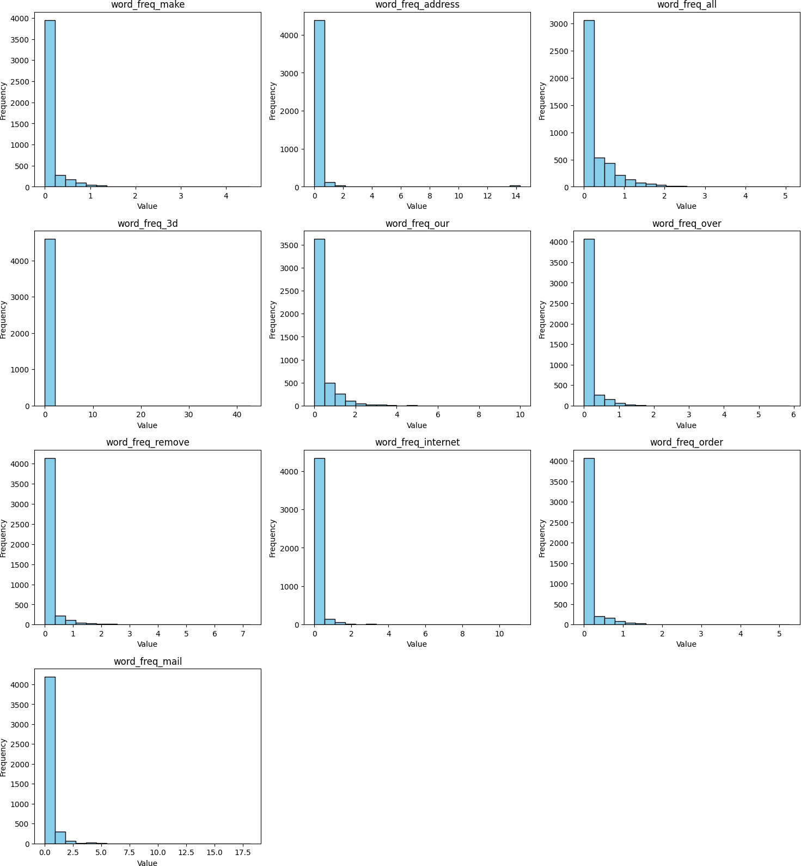

In [29]:

*#Boxplot*

numeric_cols **=** df**.**select_dtypes(include**=**['int64', 'float64'])**.**columns num_cols **=** len(numeric_cols)

*# Define subplot grid size*

n_cols **=** 3 *# number of plots per row*

n_rows **=** (num_cols **+** n_cols **-** 1) **//** n_cols *# ceiling division*

*# Create subplots*

fig, axes **=** plt**.**subplots(n_rows, n_cols, figsize**=**(15, 4 **\*** n_rows)) axes **=** axes**.**flatten()

*# Plot boxplot for each numeric column*

**for** i, col **in** enumerate(numeric_cols[:10]):

axes[i]**.**boxplot(df[col]**.**dropna(), vert**=True**, patch_artist**=True**, boxprops**=**dict(facecolor**=**'skyblue'))

axes[i]**.**set_title(col)

axes[i]**.**set_ylabel('Value')

*# Remove unused subplots*

**for** j **in** range(i **+** 1, len(axes)): fig**.**delaxes(axes[j])

plt**.**tight_layout() plt**.**show()

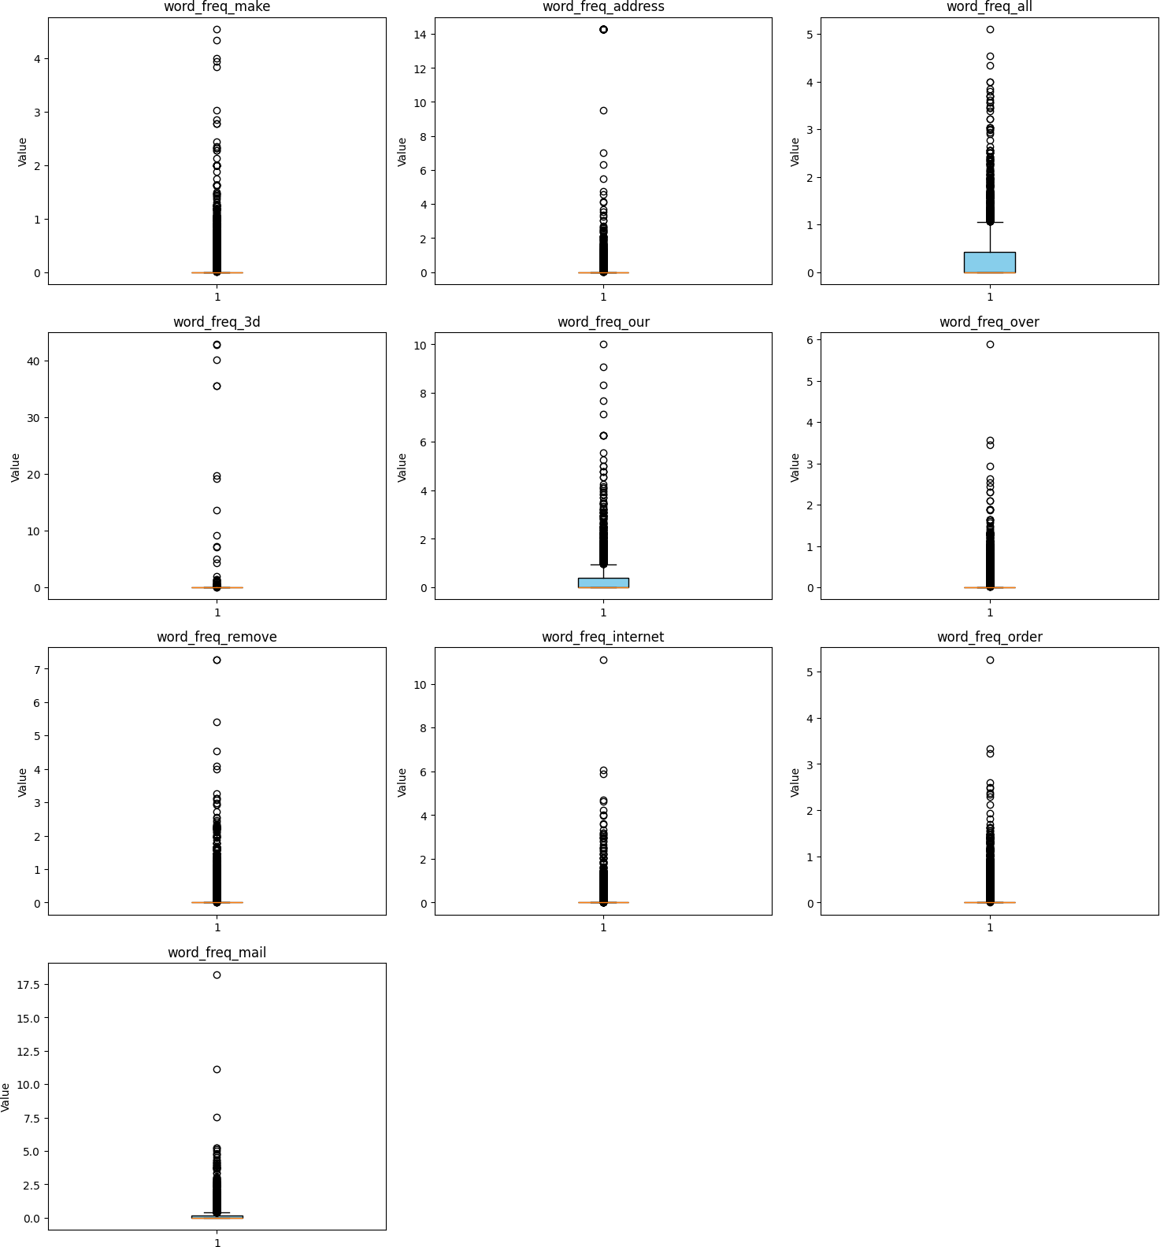

In [14]:

*#Correlation Heatmap*

plt**.**figure(figsize**=**(50,50))

corr **=** df**.**corr(numeric_only**=True**)

sns**.**heatmap(corr, annot**=True**, cmap**=**'coolwarm')

Out[14]: <Axes: >



In [15]:

*#Standardization*

X **=** df**.**drop('class', axis**=**1) y **=** df['class']

scaler **=** StandardScaler()

X_scaled **=** pd**.**DataFrame(scaler**.**fit_transform(X), columns**=**X**.**columns) df**=** pd**.**concat([X_scaled, y], axis**=**1)

print(df**.**head())

word_freq_make word_freq_address word_freq_all word_freq_3d \

0 -0.342434 0.330885 0.712859 -0.0469

1 0.345359 0.051909 0.435130 -0.0469

2 -0.145921 -0.165072 0.851723 -0.0469

3 -0.342434 -0.165072 -0.556761 -0.0469

4 -0.342434 -0.165072 -0.556761 -0.0469

word_freq_our word_freq_over word_freq_remove word_freq_internet \

0 0.011565 -0.350266 -0.291794 -0.262562

1 -0.256117 0.672399 0.244743 -0.088010

2 1.364846 0.343685 0.193644 0.036670

3 0.472573 -0.350266 0.500237 1.308402

4 0.472573 -0.350266 0.500237 1.308402

word_freq_order word_freq_mail ... char_freq_%3B char_freq_%28 \

0 -0.323302 -0.371364 ... -0.158453 -0.514307

1 -0.323302 1.086711 ... -0.158453 -0.026007

2 1.974017 0.016422 ... -0.117376 0.014684

3 0.789462 0.605857 ... -0.158453 -0.007511

4 0.789462 0.605857 ... -0.158453 -0.014910

char_freq_%5B char_freq_%21 char_freq_%24 char_freq_%23 \

0 -0.155198 0.624007 -0.308355 -0.103048

1 -0.155198 0.126203 0.423783 0.008763

2 -0.155198 0.008496 0.440053 -0.079754

3 -0.155198 -0.161934 -0.308355 -0.103048

4 -0.155198 -0.164387 -0.308355 -0.103048

capital_run_length_average capital_run_length_longest \

0 -0.045247 0.045298

1 -0.002443 0.250563

2 0.145921 2.221106

3 -0.052150 -0.062466

4 -0.052150 -0.062466

capital_run_length_total class

0 -0.008724 1

1 1.228324 1

2 3.258733 1

3 -0.152222 1

4 -0.152222 1

[5 rows x 58 columns]

In [16]:

*#Model*

**from** sklearn.neighbors **import** KNeighborsClassifier

**from** sklearn.model_selection **import** train_test_split

**from** sklearn.preprocessing **import** StandardScaler

**from** sklearn.metrics **import** accuracy_score

*#*

*# 1. Data Preprocessing #*

X **=** df**.**drop('class', axis**=**1) y **=** df['class']

*#*

*# 2. Train-Test Split #*

X_train, X_test, y_train, y_test **=** train_test_split( X, y, test_size**=**0.2, random_state**=**42, stratify**=**y)

*#*

*# 4. KNN for varying k #*

k_values **=** range(1, 21) *# vary k from 1 to 20*

accuracies **=** []

**for** k **in** k_values:

knn **=** KNeighborsClassifier(n_neighbors**=**k) knn**.**fit(X_train, y_train)

y_pred **=** knn**.**predict(X_test)

acc **=** accuracy_score(y_test, y_pred) accuracies**.**append(acc)

*#*

*# 5. Plot accuracy vs k #*

plt**.**plot(k_values, accuracies, marker**=**'o') plt**.**xlabel('Number of Neighbors (k)')

plt**.**ylabel('Accuracy')

plt**.**title('KNN Accuracy for different k values') plt**.**grid(**True**)

plt**.**show()

*#*

*# 6. Best k #*

best_k **=** k_values[accuracies**.**index(max(accuracies))]

print(f"Best k = {best_k}, Accuracy = {max(accuracies):.4f}")

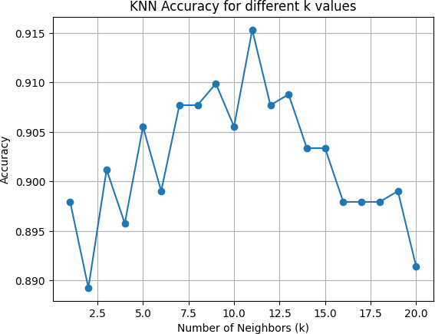

Best k = 11, Accuracy = 0.9153

In [17]:

knn **=** KNeighborsClassifier(n_neighbors**=**11) knn**.**fit(X_train, y_train)

y_pred **=** knn**.**predict(X_test)

acc **=** accuracy_score(y_test, y_pred)

print('k=11')

print('Accuracy:',acc)

k=11

Accuracy: 0.9153094462540716

In [ ]:

algo**=**'kd_tree' k**=**11

knn **=** KNeighborsClassifier(n_neighbors**=**k, algorithm**=**algo) knn**.**fit(X_train, y_train)

y_pred **=** knn**.**predict(X_test)

acc **=** accuracy_score(y_test, y_pred)

print('k=11')

print('Accuracy:',acc)

In [ ]:

algo**=**'ball_tree' k**=**11

knn **=** KNeighborsClassifier(n_neighbors**=**k, algorithm**=**algo) knn**.**fit(X_train, y_train)

y_pred **=** knn**.**predict(X_test)

acc **=** accuracy_score(y_test, y_pred)

print('k=11')

print('Accuracy:',acc)

In [18]:

**from** sklearn.metrics **import** confusion_matrix, precision_score, recall_score, f1_

y_pred **=** knn**.**predict(X_test)

y_pred_proba **=** knn**.**predict_proba(X_test)[:, 1] *# Probability for ROC*

*# ===============================*

*# 6. Metrics*

*# ===============================*

precision **=** precision_score(y_test, y_pred) recall **=** recall_score(y_test, y_pred)

f1 **=** f1_score(y_test, y_pred)

print(f"Precision: {precision:.4f}") print(f"Recall: {recall:.4f}")

print(f"F1 Score: {f1:.4f}")

*# ===============================*

*# 7. Confusion Matrix*

*# ===============================*

cm **=** confusion_matrix(y_test, y_pred) plt**.**figure(figsize**=**(5, 4))

sns**.**heatmap(cm, annot**=True**, fmt**=**'d', cmap**=**'Blues', xticklabels**=**[0, 1], yticklabe plt**.**xlabel('Predicted')

plt**.**ylabel('Actual')

plt**.**title(f'Confusion Matrix (k={k})')

plt**.**show()

*# ===============================*

*# 8. ROC Curve*

*# ===============================*

fpr, tpr, _ **=** roc_curve(y_test, y_pred_proba) roc_auc **=** auc(fpr, tpr)

plt**.**figure(figsize**=**(6, 4))

plt**.**plot(fpr, tpr, color**=**'blue', label**=**f'AUC = {roc_auc:.4f}') plt**.**plot([0, 1], [0, 1], 'r--')

plt**.**xlabel('False Positive Rate') plt**.**ylabel('True Positive Rate') plt**.**title(f'ROC Curve (k={k})') plt**.**legend()

plt**.**show()

|  |  |
| --- | --- |
| Precision: | 0.9107 |
| Recall: | 0.8705 |
| F1 Score: | 0.8901 |

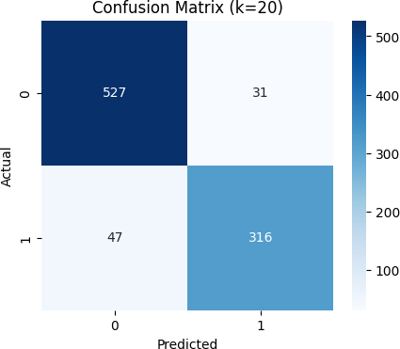

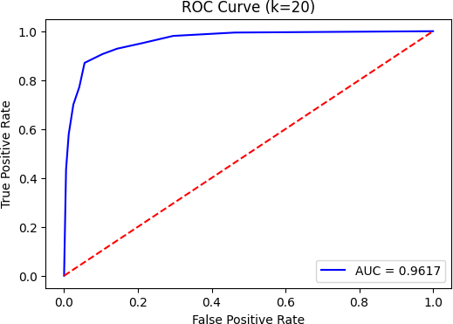

In [19]:

*# ===============================*

*# 9. K-Fold Cross Validation (K=5) # ===============================*

**from** sklearn.model_selection **import** StratifiedKFold, cross_val_score print("\nK-Fold Cross Validation (k = 11)")

kfold **=** StratifiedKFold(n_splits**=**5, shuffle**=True**, random_state**=**42)

cv_scores **=** cross_val_score(KNeighborsClassifier(n_neighbors**=**11), X, y, cv**=**kfold

print(f"Mean Accuracy: {cv_scores**.**mean():.4f}")

print(f"Standard Deviation: {cv_scores**.**std():.4f}")

K-Fold Cross Validation (k = 11) Mean Accuracy: 0.9081

Standard Deviation: 0.0097

In [20]:

*# ===============================*

*# 10. Compare and Record Observations # ===============================*

**import** pandas **as** pd best_k**=**11

metrics_data **=** {

"Best_k": [best_k],

"Accuracy": [acc],

"Precision": [precision], "Recall": [recall],

"F1-Score": [f1],

"ROC AUC": [roc_auc],

"CV Mean Accuracy": [cv_scores**.**mean()], "CV Std Dev": [cv_scores**.**std()]

}

results_df **=** pd**.**DataFrame(metrics_data)

print("\nFinal Evaluation Metrics Summary:") print(results_df)

Final Evaluation Metrics Summary:

|  |  |  |  |
| --- | --- | --- | --- |
| 0 | Best_k  11 | Accuracy  0.915309 | Precision Recall F1-Score ROC AUC \  0.910663 0.870523 0.890141 0.961714 |
| 0 | CV Mean | Accuracy 0.908064 | CV Std Dev 0.00968 |

# Naïve Bayes,

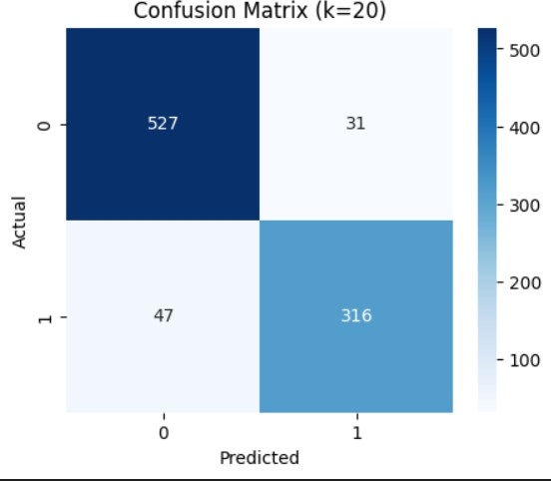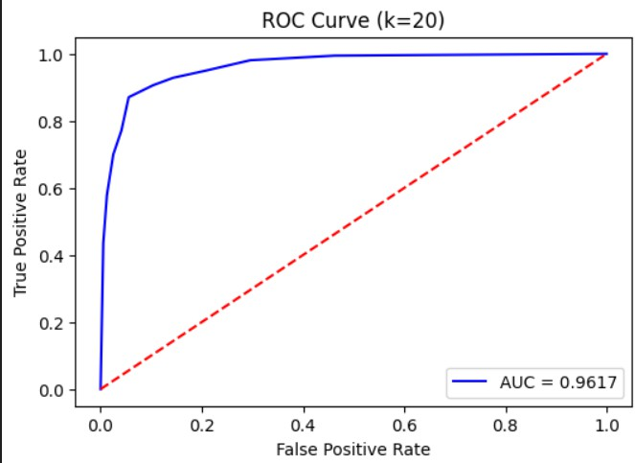

**Bernoulli,**

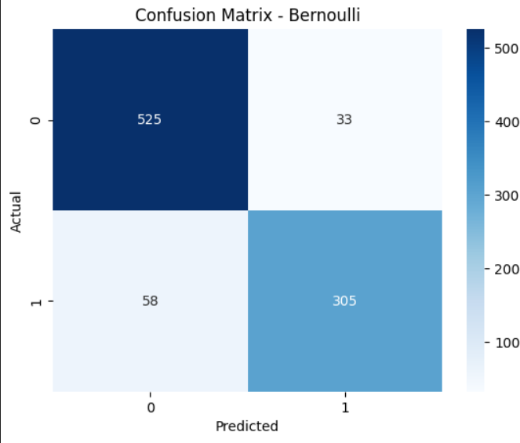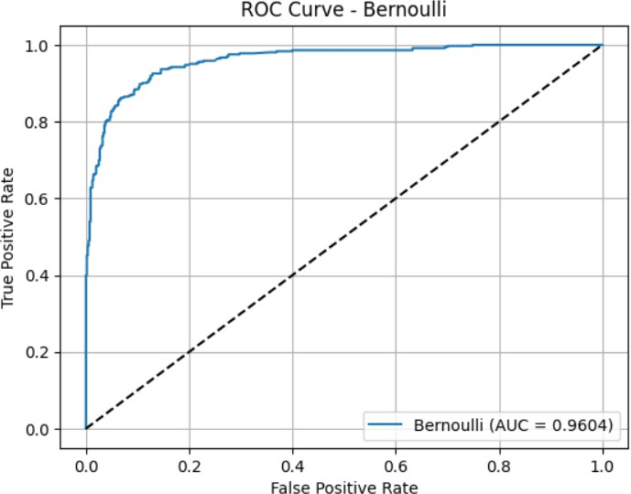

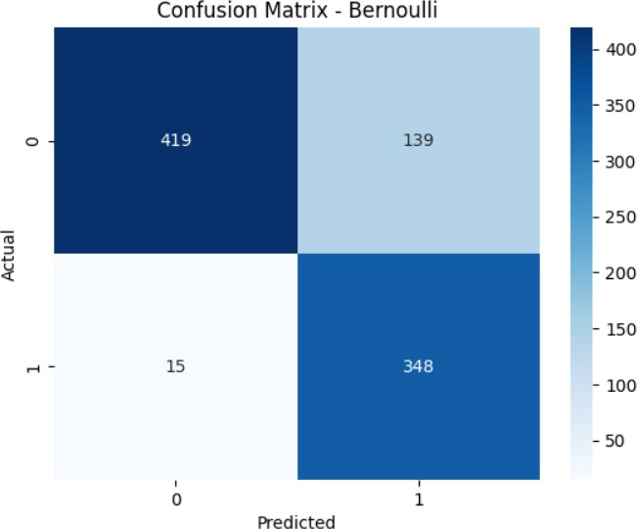 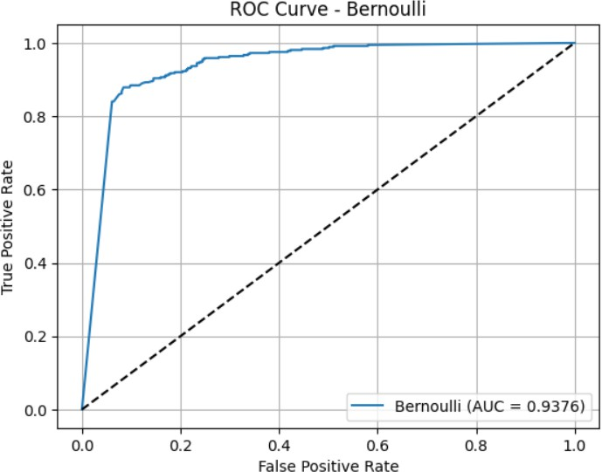

# Multinomial,

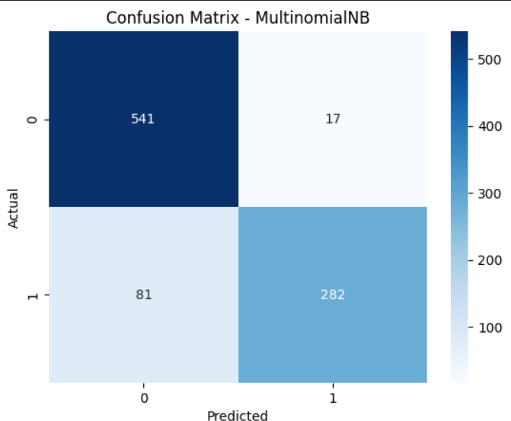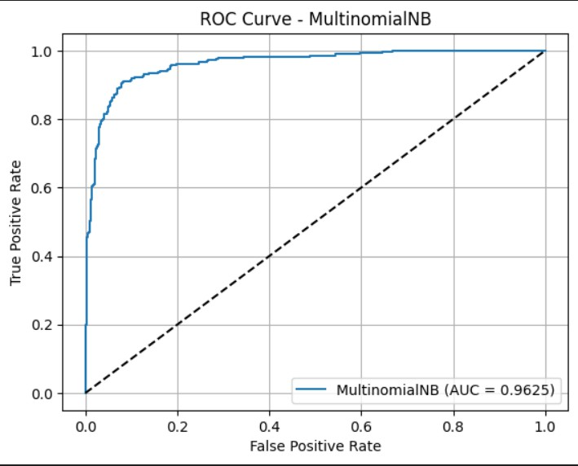

**Polynomial,**

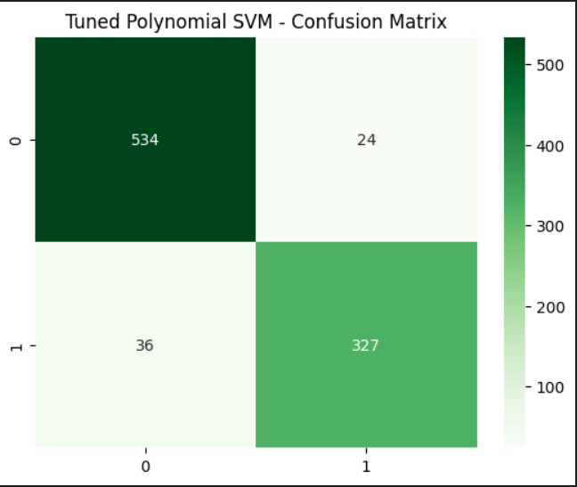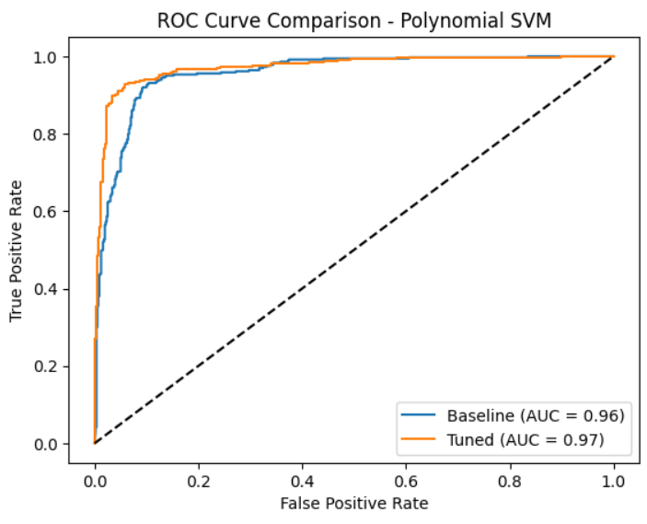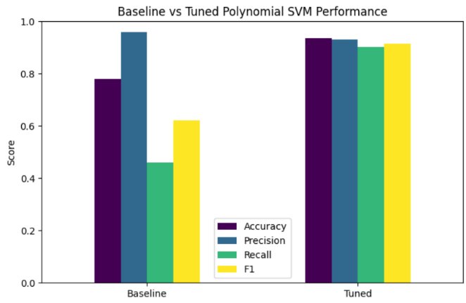

**RBF,**

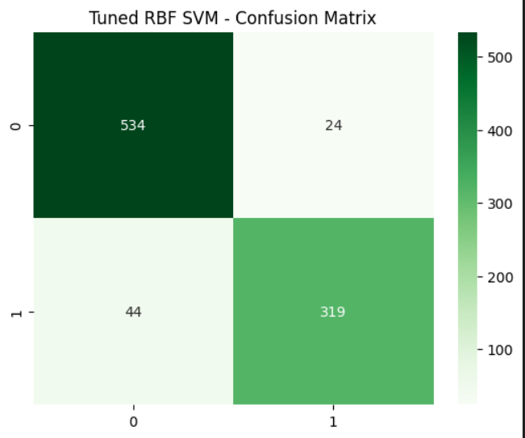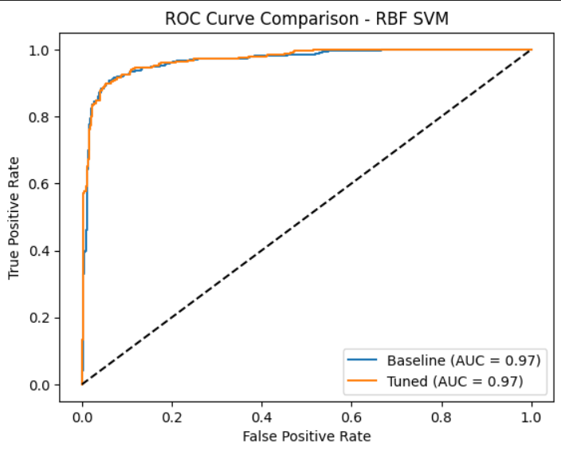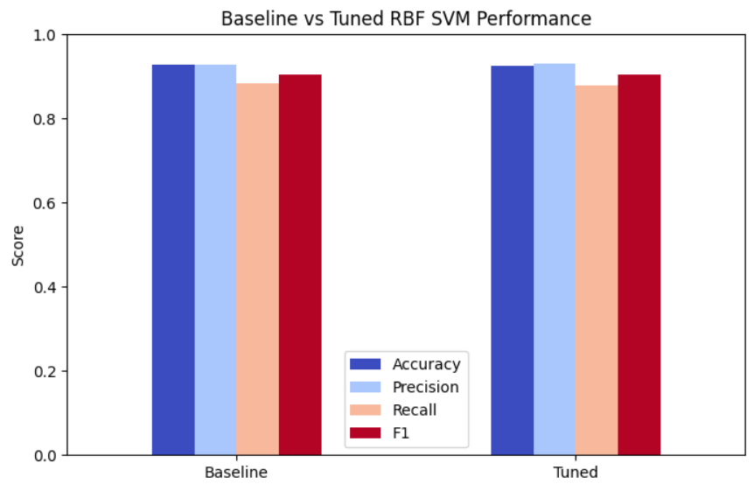

**Sigmoid,**

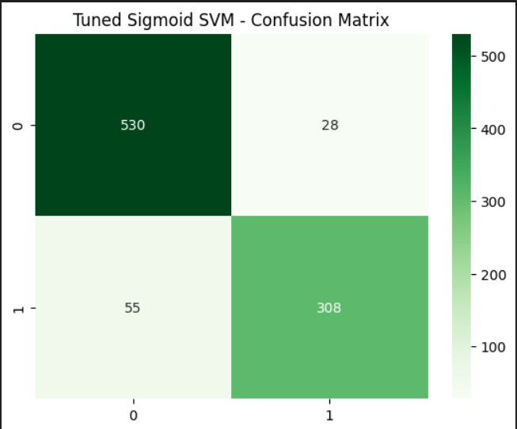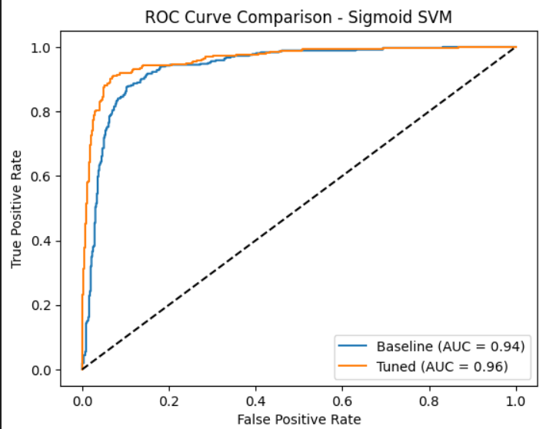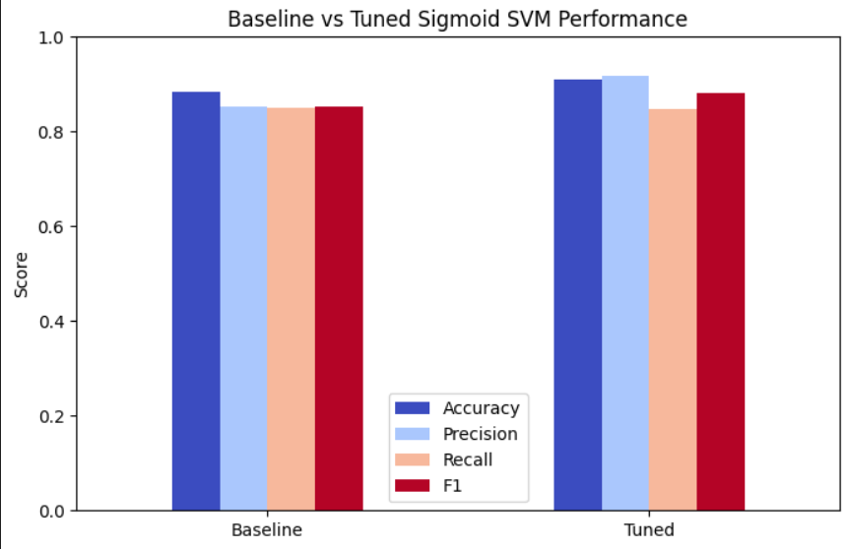

**6 Comparison Table**

Performance Comparison of Naïve Bayes

|  |  |  |  |  |
| --- | --- | --- | --- | --- |
| Model | Accuracy | Precision | Recall | F1 Score |
| Bernoulli NB | 0.9012 | 0.9024 | 0.8402 | 0.8702 |
| Multinomial  NB | 0.8936 | 0.9431 | 0.7769 | 0.8520 |
| Gaussian NB | 0.8328 | 0.7146 | 0.9587 | 0.8188 |

KNN Performance for different k values

|  |  |  |  |  |
| --- | --- | --- | --- | --- |
| K | Accuracy | Precision | Recall | F1 Score |
| 1 | 0.8899 | 0.8551 | 0.8676 | 0.8613 |
| 3 | 0.8892 | 0.8741 | 0.8652 | 0.8574 |
| 5 | 0.8993 | 0.8828 | 0.8585 | 0.8705 |
| 7 | 0.8950 | 0.8815 | 0.8474 | 0.8641 |

KD tree vs Ball tree

|  |  |  |
| --- | --- | --- |
| Metric | KD Tree | Ball Tree |
| Accuracy | 0.9153 | 0.9153 |
| Precision | 0.9107 | 0.9107 |
| Recall | 0.8705 | 0.8705 |
| F1 Score | 0.8901 | 0.8901 |
| Training Time | 0.4470 | 0.4058 |

SVM Performance

|  |  |  |  |  |
| --- | --- | --- | --- | --- |
| Kernel | Hyperparameter | Accuracy | F1 score | Training Time |
| Linear | C=100 | 0.9272 | 0.9065 | 10m 35s |
| Polynomial | C=1,degree=2,gamma=scale | 0.9348 | 0.9159 | 1m 52s |
| RBF | C=10,gamma=0.01 | 0.9272 | 0.9036 | 35s |
| Sigmoid | C=1,gamma=0.01 | 0.9098 | 0.8812 | 21s |

# 7 Observation:

* KNN (k=1) consistently achieved higher accuracy across all 5 folds compared to Multinomial

Na¨ıve Bayes, with an average accuracy of 90.39 percentage vs 88.63 percentage.

* Na¨ıve Bayes showed slightly more stable performance across folds, whereas KNN had slightly

higher variance but better peak performance (e.g., Fold 3 with 91.52 percentage).

* KNN’s superior accuracy suggests that instance-based learning works better for this dataset,

possibly due to well-separated class boundaries that KNN can capture using distance metrics.

# 8 Conclusion:

* KNN (k=1) outperformed Multinomial Na¨ıve Bayes in terms of average accuracy in 5-fold cross-validation, making it the better choice for this dataset.